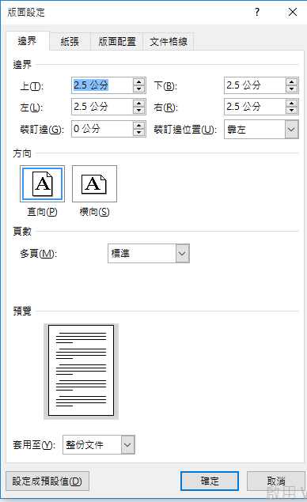
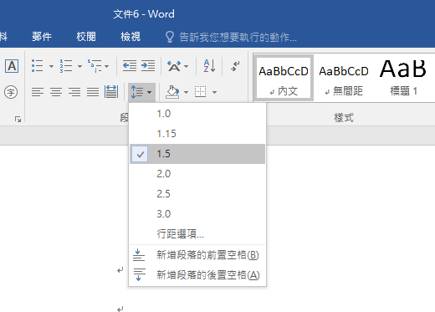
Title of RP (#12)

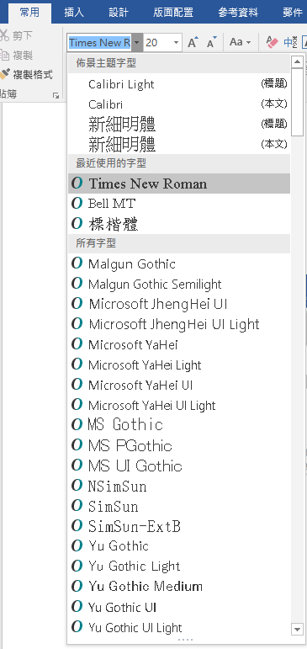
Turcy Lin (598201293) (#12)

Composition III, A (BCD) May 13th, 2019

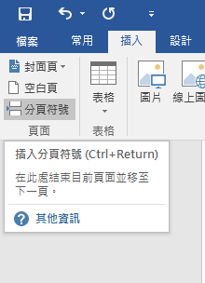

Turcy Lin (598201293) Composition III, A (or B.C.D.E) Research Paper
May 16th, 2016
Lin i

(Title): an Outline

- Introduction: sdfghjkrtyu
  - Truigjfkl
  - Jgleog
- Literature Review
  - Fhdfhd
  - Gdsgh
- Methodology
- Main discussion: ertyxcvbnmghj
  - Hfdkfnlwo
    - Vkllrio
    - Gjp[wm
    - Gjomgb
      - Ihrkvlpe
      - Ioklgpe
        - Rfghjk
        - Njflorp
        - Phgmow
  - Vlrtehjlvnml
    - Fdhh
    - Dsgfhd64
  - Jrtoimvxft;
- (Result)
- Conclusion: ujikmtgerdf
Workes Cited or Reference
Appendix

Lin ii

Abstract (#12)
Dfgvbhnjmkyuimkoyuhjkkllp;lkiytftvhjnnojojljmlhuygbhgytgbknjojml;,ml;,l;juiuhuybvt rdfvhbkniuhkm;kpuigygnuhbtkmpoj,m (#12) (200-250 wordss)

Keywords: (within 10 words)

(Title)
Lin 1

Works Cited (#12) (in Alphabetical order of the last names)

